Join the conversation using Sli.do
To join the session, go to Slido.com and enter the event code: #eventcode

Select the ‘’Q&A’’ tab to answer questions
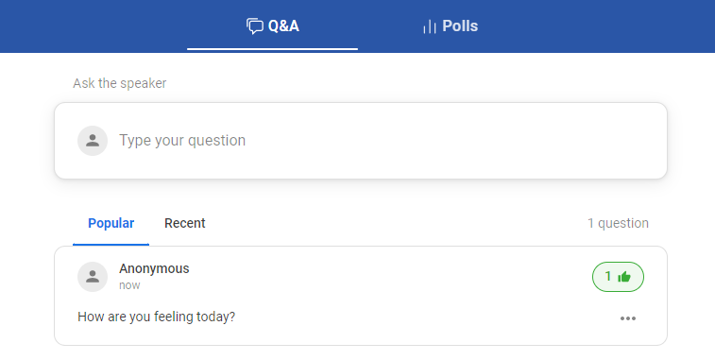

Stay anonymous or attach your name to the question
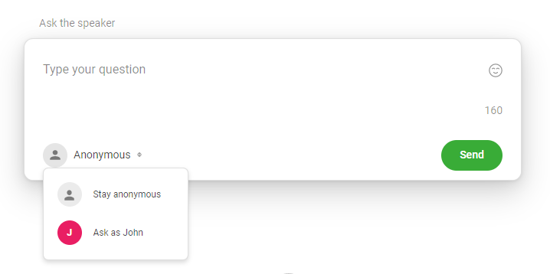

Select the ‘’Polls’’ tab to share your thoughts and opinions by voting in live polls
